**Program no____12_____**

**Program Title  display system to print the RED,BLUE and Green colors (RGB Led and LCD).**

1. **Aim To display the color of the light**

**Hardware Required**

* Arduino Board
* LCD
* RGB LED

**Circuit Diagram**

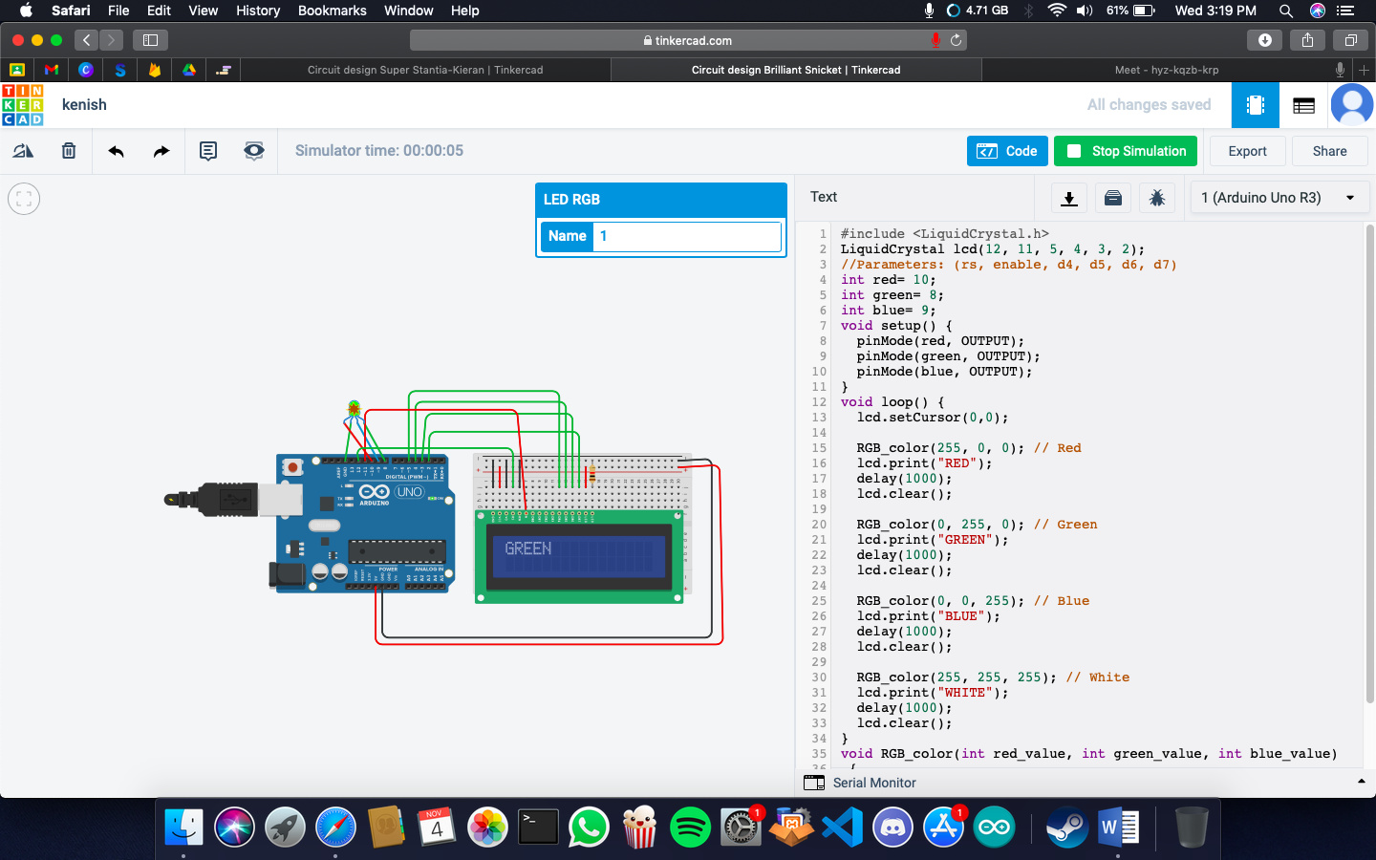

CODE: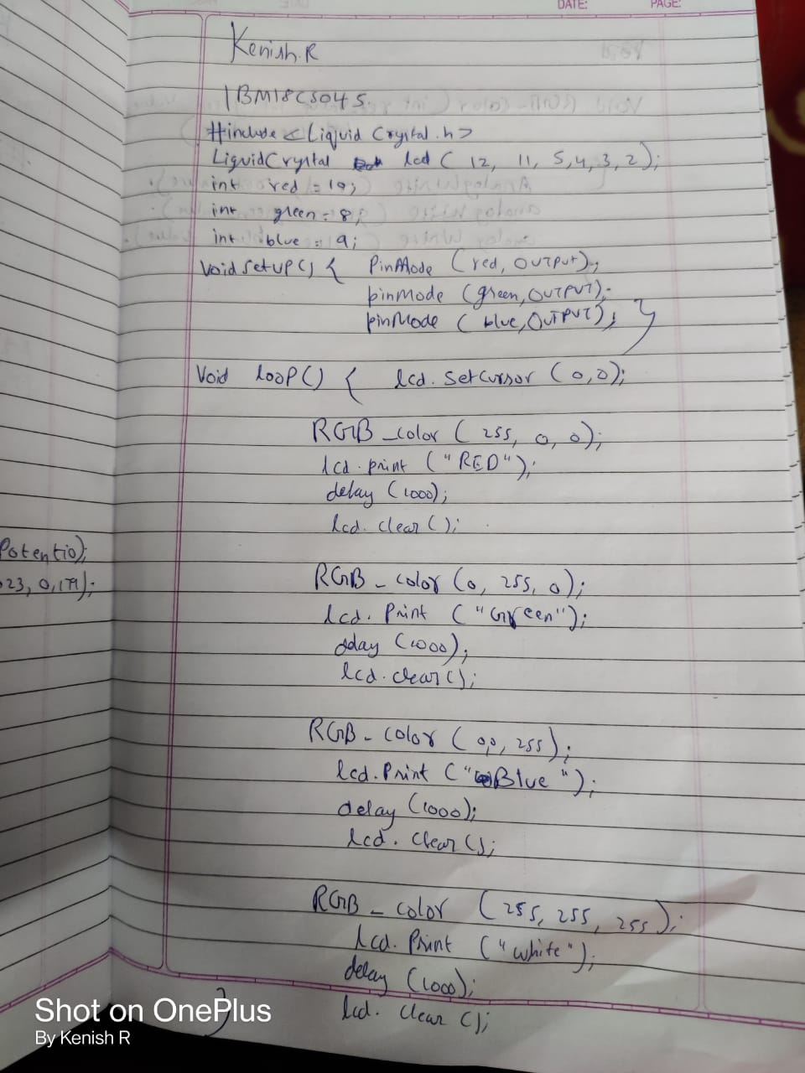

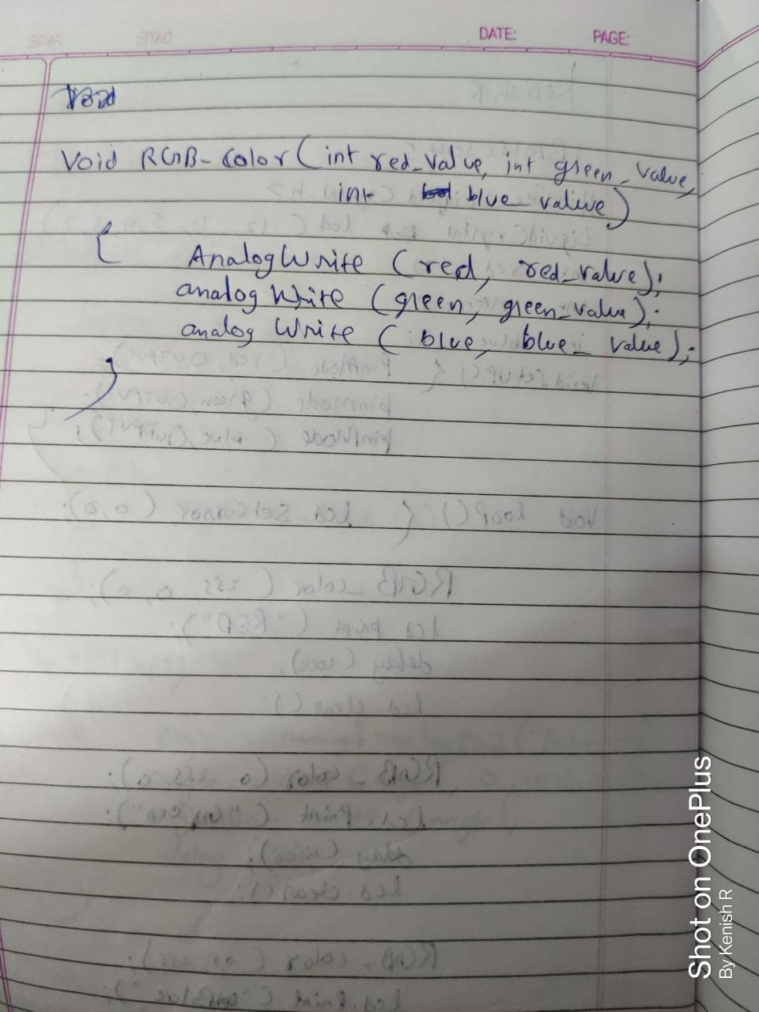

**Observation /Output**

**displays RED,BLUE and Green colors (RGB) Led on the LCD.**